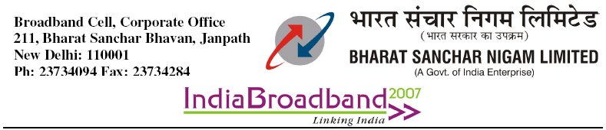
No: 64-17/09-Broadband Dt: 12-10-09
To:
The DGM(IT), UP(W) Circle
DGM(Mktg), Chennai Telephones

Sub: Broadband connectivity to Rural /Remote Exchanges-USOF agreement
Ref: Lr.No:UPW/IT & BB/USO subsidy claim/Rural BB/2008-09/50 dt 25-09-09 &
Lr.No: DGM(Mktg)/BB/2009-10/53 dt 06-10-09 from Ch.TD

With ref. to the above the following clarifications are given for further nec. Action at your end pl.

- Query(From UP(W) circle): As per clarification issued by USOF HQ, DoT vide Letter No:1-16/2009-USOF/697-719 dt 15-07-09” Only rural NN connections provided with minimum speed of 512 kbps shall be eligible for subsidy.- But subsidy has been claimed by BSNL in respect of connections provided under various plans having minimum speed less than 512 kbps. There are 142 such connections provided for the Q/E 30th June 2009.
Reply: As per clause 15.4.2 of the agreement “ Throughput of each of the broadband connection, provided under the Agreement, shall be at least 512 kbps always on.” In this connection, Dot Lr:1-16/2009-USOF(BB-LL) dt 7th Aug-09 circulated vide this office L:r.No: GM(BP-CFA)/64-17/09-BP dt 31-08-09 may be referred to pl.

- Query: Since there are USOF subsidized plans @ Rs 150/- & Rs 99/- with the downlosd limit of 1 GB & 400 MB respectively with minimum speed of 512 Kbps, the plans H-250 & H-125 which have similar/less download limits with minimum speed of 256 Kbps are not eligible for subsidy. It is observed that these Non-USOF plans are being provided instead of USOF plans by most of the SSAs.ot even a single USOF plan has been provided in Bareilly & Moradabad SSAs whereas 18 & 20 connections respectively have been provided by these SSAs under Plan H-250/H-125.

Reply: Same as Reply to Query No-1 pl. The case for subsidy for 256 kbps plans was taken up with USOF(A), but the same has been regretted from DoT

- Query( From T.N. Circle): It is clarified that subsidy relating to computer/computing devices shall be provided by USOF for connections on uSOF plans USOF (( & USOF 150 only. It may further be clarified whether the free CPE(ADSL Type-I Modem) along with associated conditions of no registration charges, security deposit & installation charges is also applicable to USOF plans with Novatium Net PC connection also.

Reply: As per clause 17.1 of the agreement” The subsidy support for CPEs shall be Rs. 850/- and for computing devices/computers, it shall be Rs. 4500/- on net addition basis, limited up to 31 numbers of CPEs and computing devices/computers per DSLAM”. As such, subsidy can be claimed for CPEs & computing devices for net 31 BB connectioons

4. It is observed that some circles are claiming subsidy for service connections also. The same are not eligible for Subsidy.In this connection, Lr.No1-16/2009-USOF(BB-LL)/1646-69 received from Dy.Administrator(F), DoT is enclosed for reference pl

-Sd
(M.S.T.Sundari)
AGM(S & M), CFA

Copy to: 1. All Heads of circles for information & nec.action pl.
2. Dy.Administrator(F), USOF section, DoT for information pl

